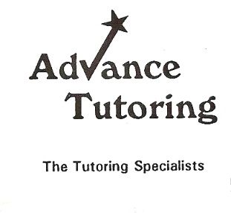
Analysis Outline
Write a one page reaction using the following outline>
Who-wrote the literature?
What-was it about/ is the Symbolic meaning of the literature?
When-was the literature written?
Where- was the literature written?
Why-is this literature significant (2-3 reasons if possible)?
How- should the reader be changed after reading the literature?
What is the “moral of the story” or lesson for the reader?

