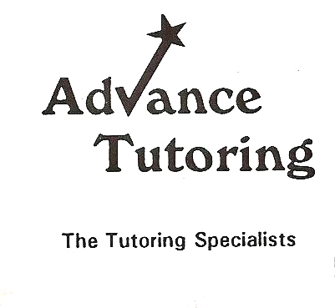
Essay Overview
An example of a thesis statement is; The Washington Nationals had a losing season due to poor coaching, bad draft picks and injuries.
The thesis should be a single, unified statement.
The thesis statement should be in the introduction and conclusion of the essay (word for word).
Each body paragraph should support one or more reasons why of your thesis.
The body paragraphs should also relate and explain the relationship to the thesis at the end of the paragraph- (transitional relation).
The conclusion of the essay should be a re-statement of the thesis word for word and a ‘moral’ of the essay.
The ‘moral’ of the essay involves how the reader should be changed after they read your essay-what should they have learned?
What is the lesson of your essay? You are the ‘teacher’ as the writer.

Thesis Overview *
- Determine what kind of paper you are writing:
- An analytical paper breaks down an issue or an idea into its component parts, evaluates the issue or idea, and presents this breakdown and evaluation to the audience.
- An expository (explanatory) paper explains something to the audience.
- An argumentative paper makes a claim about a topic and justifies this claim with specific evidence. The claim could be an opinion, a policy proposal, an evaluation, a cause-and-effect statement, or an interpretation. The goal of the argumentative paper is to convince the audience that the claim is true based on the evidence provided.
- If you are writing a text which does not fall under these three categories (ex. a narrative), a thesis statement somewhere in the first paragraph could still be helpful to your reader.
- Your thesis statement should be specific—it should cover only what you will discuss in your paper and should be supported with specific evidence.
- The thesis statement usually appears at the end of the first paragraph of a paper.
- Your topic may change as you write, so you may need to revise your thesis statement to reflect exactly what you have discussed in the paper.
- Example of an analytical thesis statement:
An analysis of the college admission process reveals one challenge facing counselors: accepting students with high test scores or students with strong extracurricular backgrounds.
The paper that follows should:
explain the analysis of the college admission process
explain the challenge facing admissions counselors
Example of an expository (explanatory) thesis statement:
The life of the typical college student is characterized by time spent studying, attending class, and socializing with peers.
The paper that follows should:
explain how students spend their time studying, attending class, and socializing with peers
Example of an argumentative thesis statement:
High school graduates should be required to take a year off to pursue community service projects before entering college in order to increase their maturity and global awareness.
The paper that follows should:
present an argument and give evidence to support the claim that students should pursue community projects before entering college
*Source-Purdue University Owl

Critical Writing-Analysis of Argument
Author Thesis
Author Purpose-persuade or report?
Author Persona-rhetorical strategies

