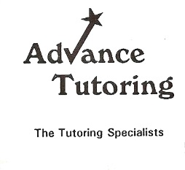
*Check out a few poetry books from MFR Library, try to read a poem aloud each day (and talk about what you
think it means). If any of the poems stand out during your readings you can mark them and we will
talk about them during our sessions. When you read the poem out loud, follow that up by asking yourself what you think it
means and free write about that for several paragraphs.
Use Critical Interpretive Lenses @ http://wvarts-tutoring.weebly.com/resources.html
and the following outline as well>
Who-was the poem about?
What-is the poem about?
When- was the poem written?
Where-was the poem written?
Why-is the poem significant or important?
How-have you been changed after we read that poem?

If you think the poem has no purpose, ask why that is and give 2-3 reasons (written down).
You may also replace the poem with a short story, a bit of scripture or
a newspaper article if needed as well.

Using the outline will help when you begin to tackle essay writing down the road as well.

I also think it helps to have a really good English handbook of some kind on hand and you may
want to check out http://amzn.com/0669416681 the Concise English Handbook by Kirkland and Dilworth

