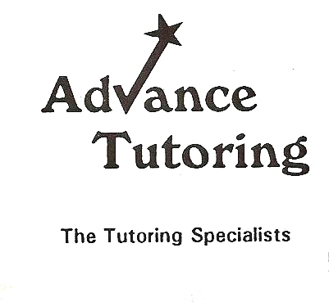

Recommended Reading:
Hermann Hesse- Siddhartha
Hermann Hesse- Journey To The East
Nathaniel Hawthorne-Great Short Works
Sherwood Anderson-Winesburg, Ohio

Available @
http://www.lib.vt.edu/
http://www.amazon.com/

